*Name:* *dalia khaled* *mohamed*

*B.N: 20*

*sitting number: 297*

*Date: 8/6/2021*

*Topic: artificial intelligence*

*Application breif:*

*AnWriter Free HTML: Editor is a useful app that offers a simple and efficient way to write and edit source code right from your smartphone. This editor supports a variety of languages, including HTML, HTML 5, CSS, CSS 3, JavaScript, jQuery, Bootstrap, and Angular.*

*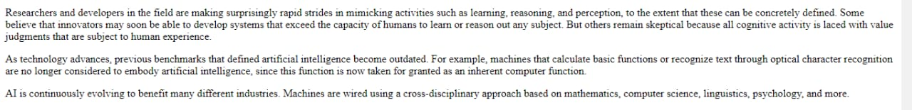****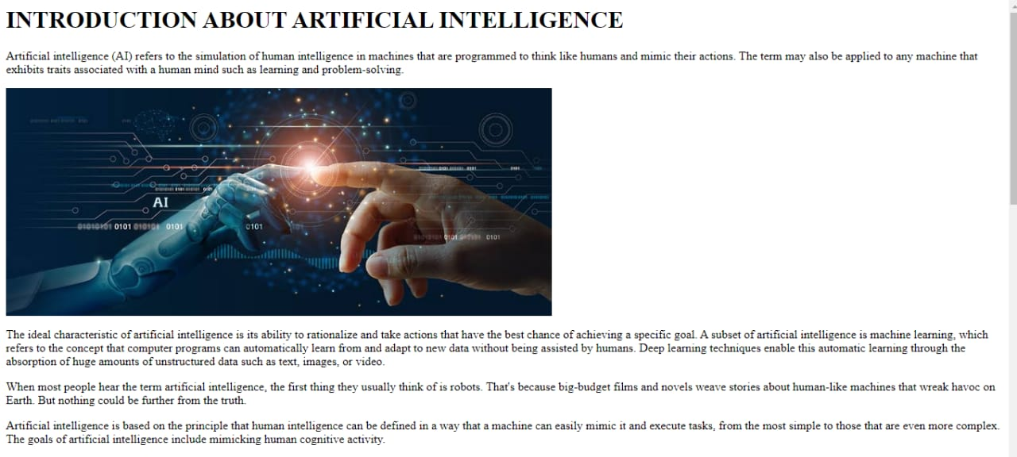Screenshots:*** 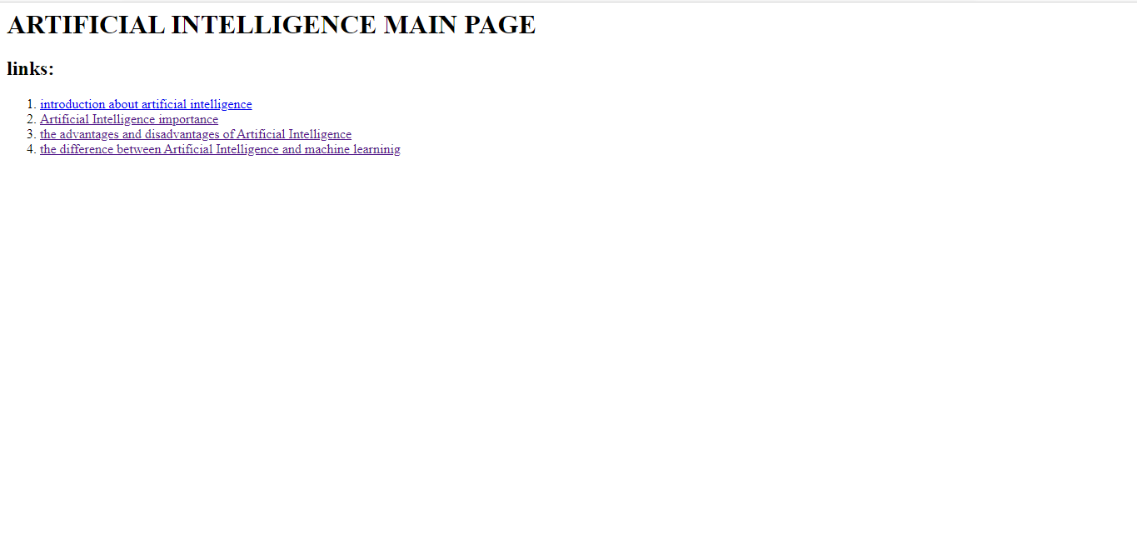

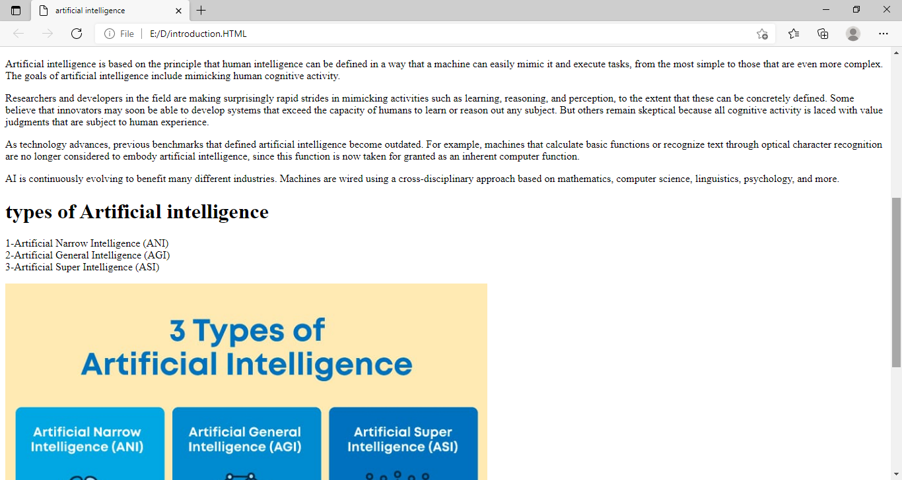

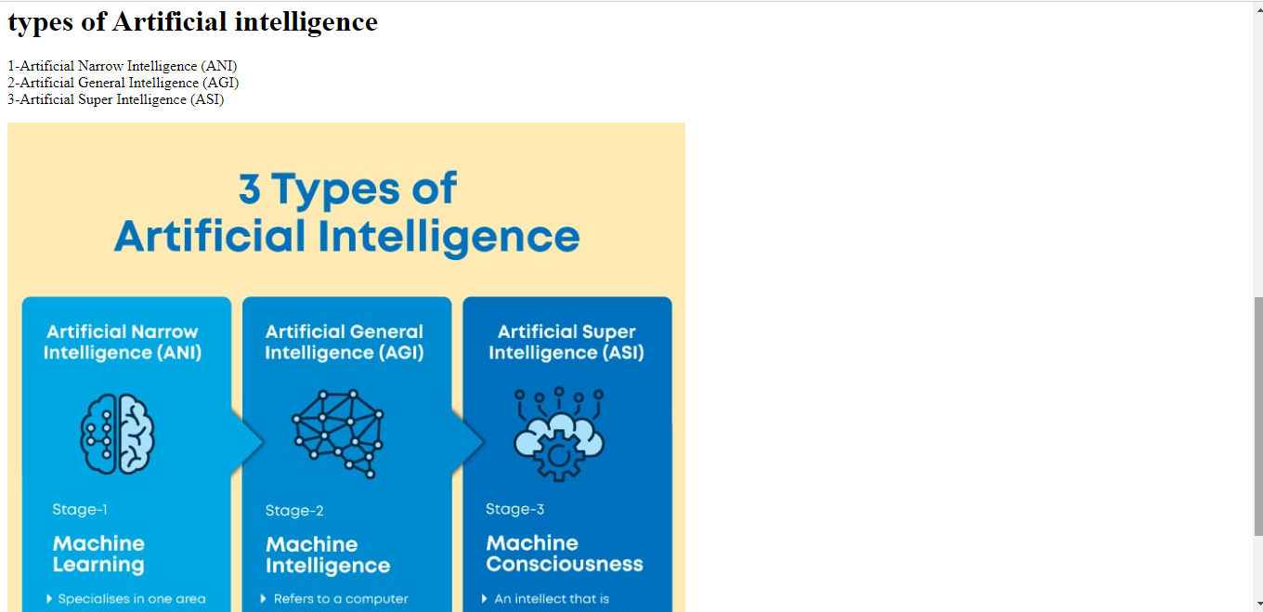

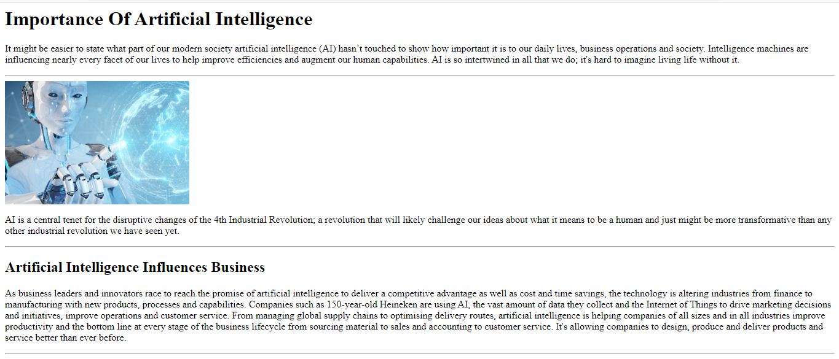

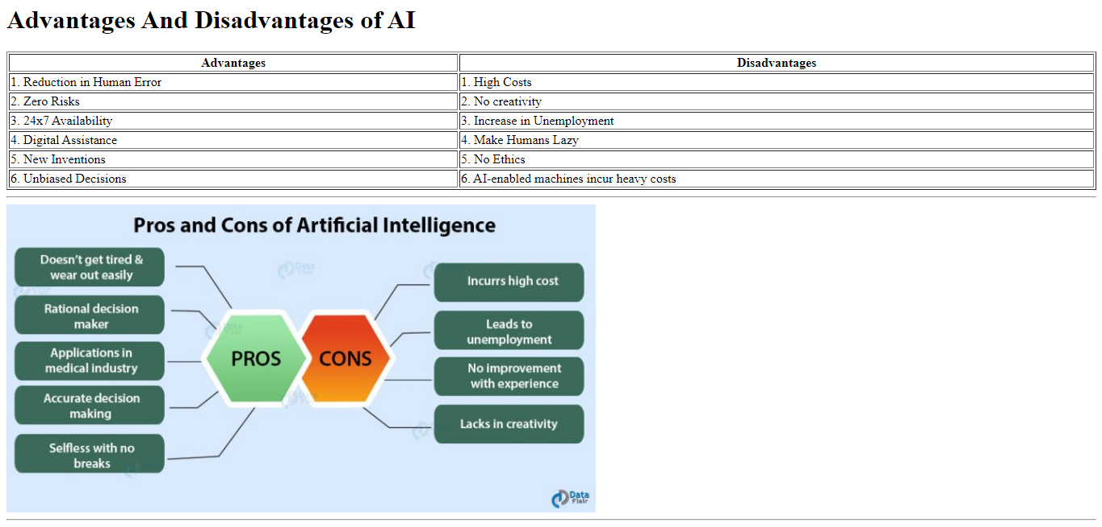

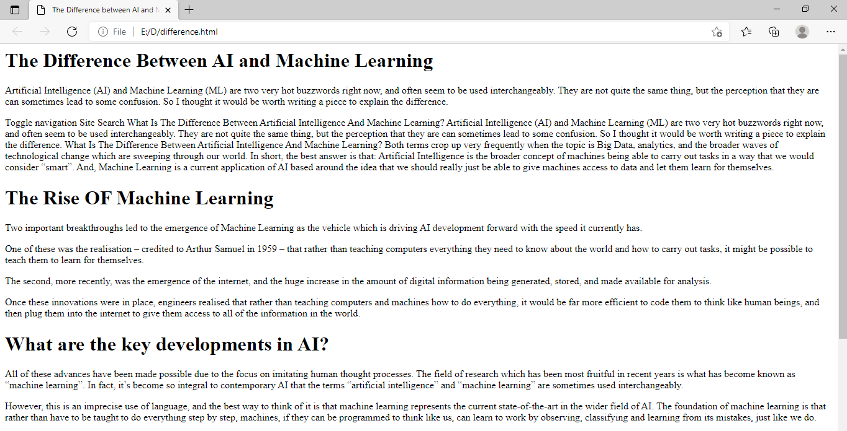

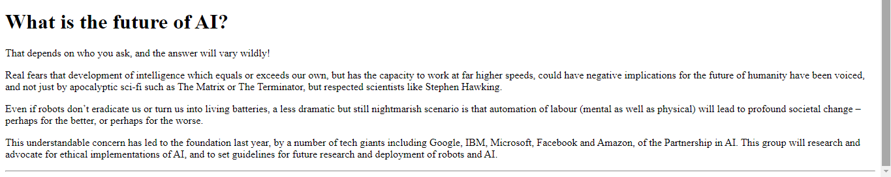

***source code:***

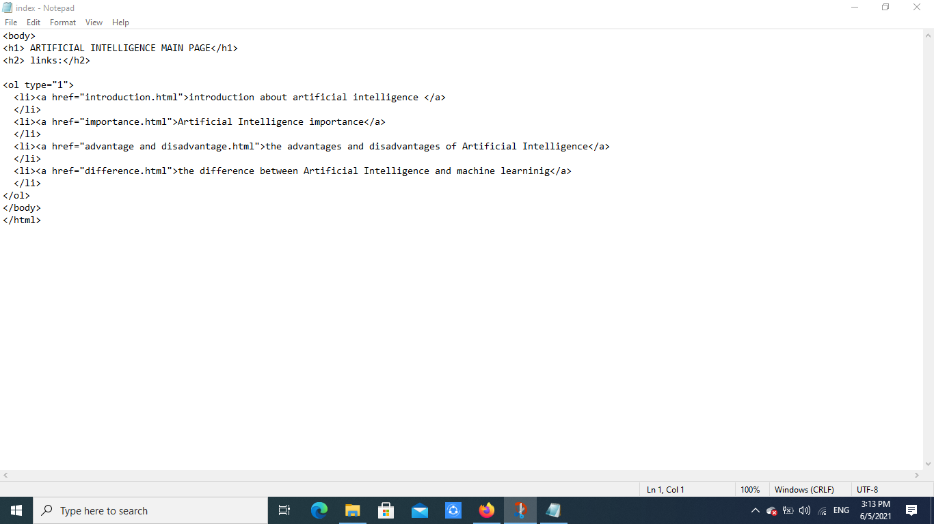

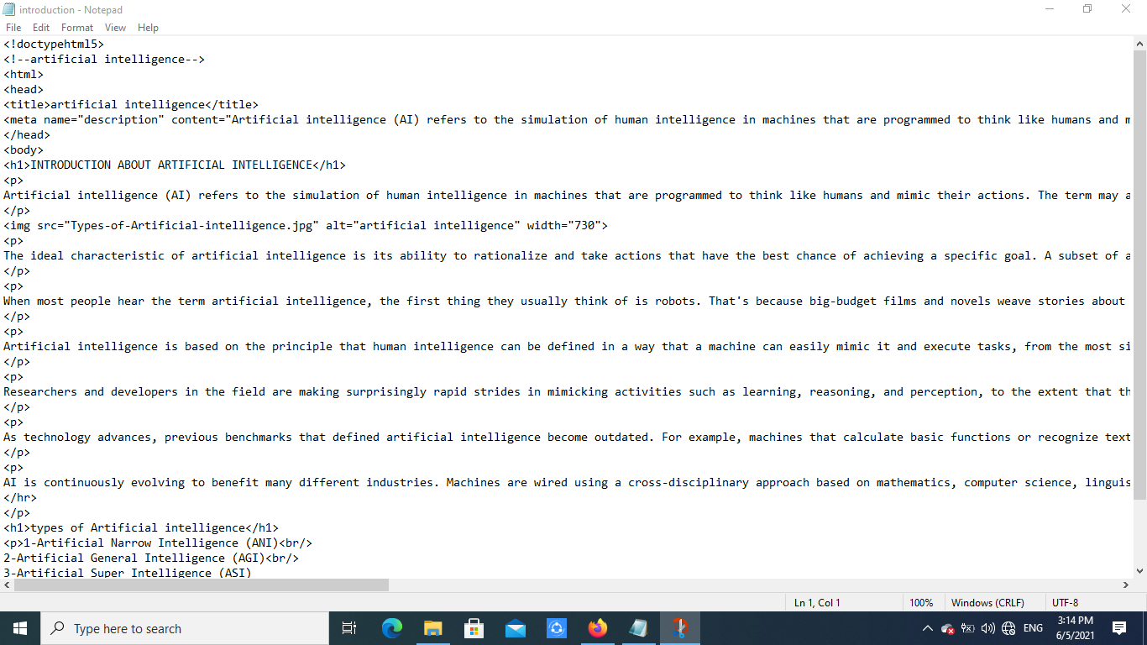

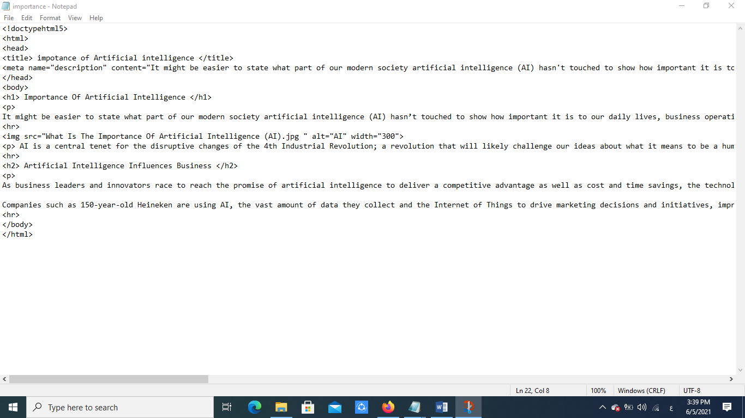

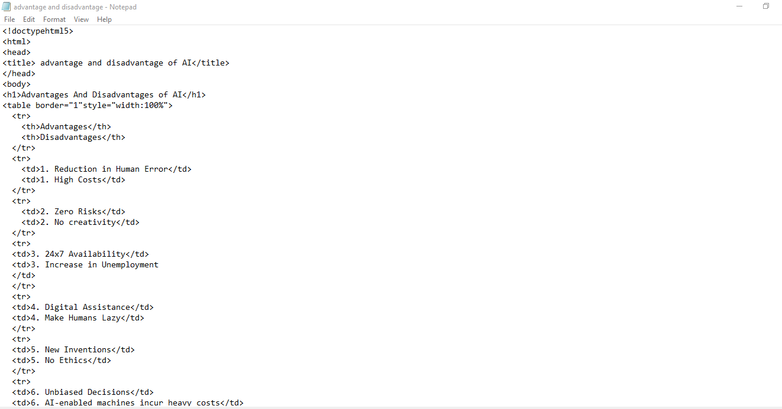

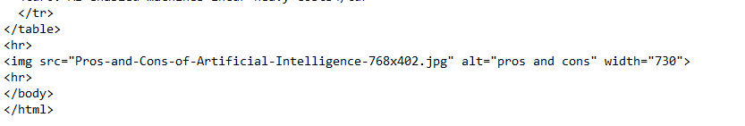

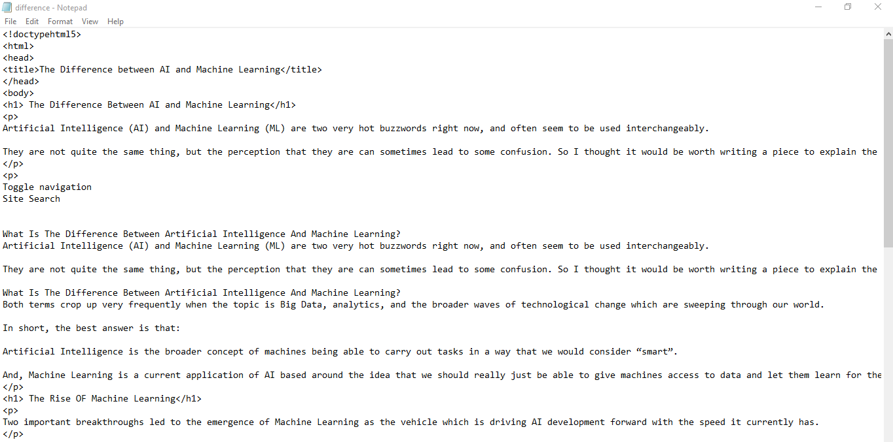

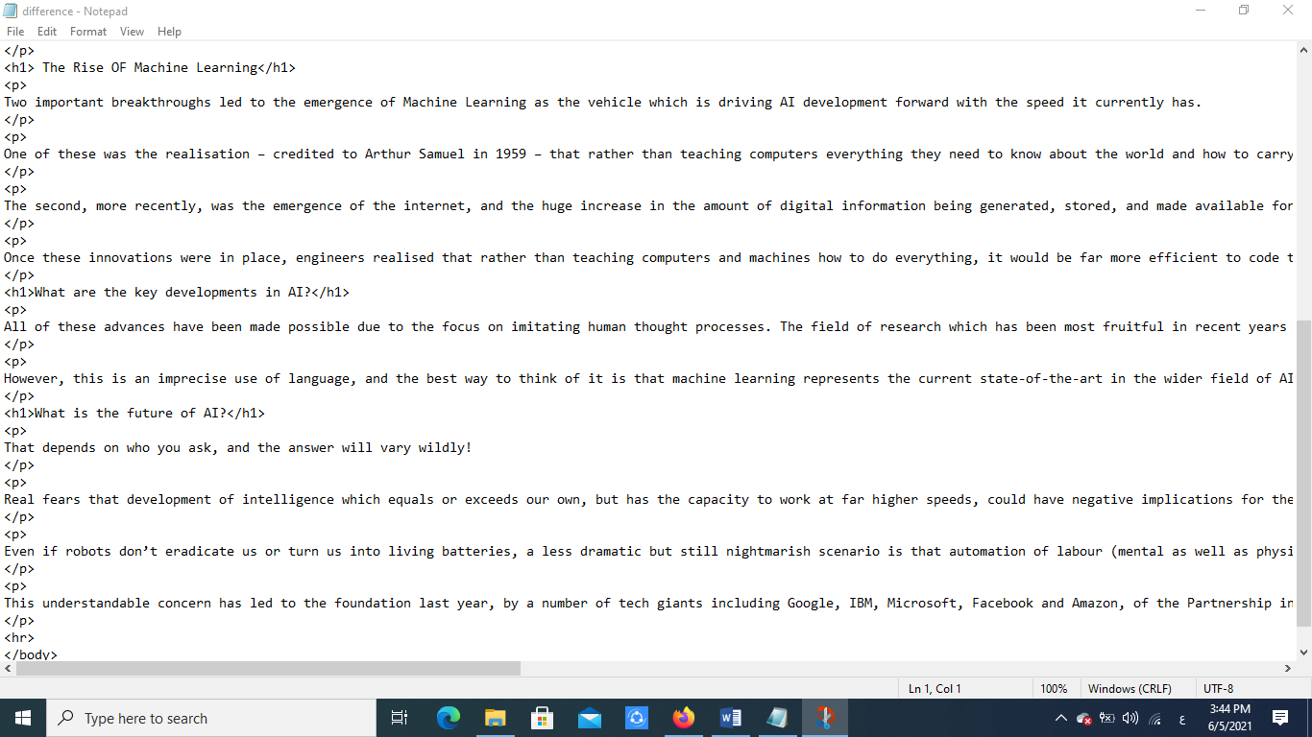

***Github link:***